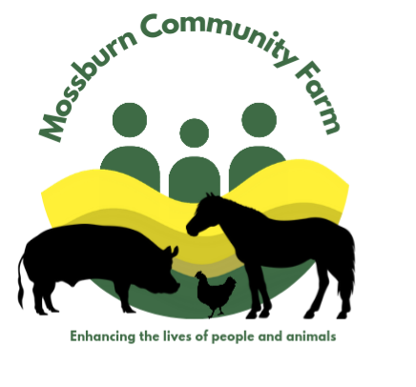

Mossburn Community Farm
Animal Assisted Learning
Information Pack

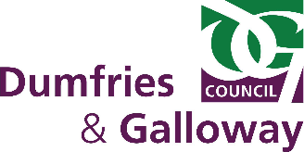
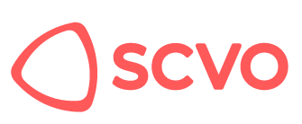
Supported by:

Adapt & Thrive

Animal Assisted Learning
Animal Assisted Learning (AAL) employs the presence of animals in a natural setting to support people with personal and professional development.
At Mossburn Community Farm all AAL sessions are facilitated by trained professionals, and are tailored to each individual client’s specified needs to ensure individuals benefit from positive learning experiences.

Benefits of Animal Assisted Learning
AAL offers direct contact with animals in a natural setting to help individuals who are experiencing difficulties within a traditional educational environment. Although there is no direct Animal Assisted Therapy component, those taking part in AAL benefit from time spent outside, in a natural setting and with animals and the innate capacity of this environment in reducing stress and improved mental health.
AAL can help with personal and social development, increased self-esteem, improved mental health, better social skills, and increased empathy and nurturing skills. At Mossburn sessions are typically active and outside, meaning that physical activity and fresh air and the associated benefits of both are almost guaranteed.

Our Animals
Currently at Mossburn there are approximately 100 animals on site including horses and ponies, goats, pigs, rabbits and guinea pigs, sheep, cattle, chickens, as well as an emu and two tortoises.
During any particular AAL session, the opportunity to engage with a variety of the animals will occur with the needs and preferences of the individual being taken into account.

AAL Sessions
AAL takes a holistic approach to learning and development through the variety of opportunities and activities that occur across the session.
Each session is designed to meet the specific needs of those taking part, therefore no two sessions are identical although many of the same elements and activities may be present.
Some typical activities include:
- Grooming and taking a pony for a walk. This helps individuals establish a friendship with the animal and develop communication skills such as giving voice commands, active listening, adapting communication style, confidence, volume and clarity. Empathy, respect, responsiveness and body language also develop. Riding is not offered as part of AAL at Mossburn.
- Sitting in a calm environment with the animals. Being around animals in a rural farm setting results in the stress being reduced and therapeutic discussion taking place.
- Engaging in animal care tasks around the farm. Active listening skills, taking instruction and staying task focused are key parts of animal care. Task completion benefits self-esteem and can alter individual self-perception.
- Exploring the woodland area at the farm and taking part in play based learning activities.
While AAT sessions are on a one-one basis, AAL take place in small groups, the aim of the sessions is to increase the opportunities for peer social interaction, as well as scenarios where empathy, patience and sharing can be developed.
The number of sessions per individual are not limited and run on an open ended basis for as long as both the participant and Mossburn feel they are benefiting from AAL.
Sessions are competitively priced and subsidised by other funding at Mossburn Community Farm to ensure they are as affordable as possible. Group sessions cost £25 per session from 10am till 3pm or half day group sessions cost £10 per session from 1pm till 3pm.

Referral Process
Schools, agencies, or individuals who feel they may benefit from AAT should contact Mossburn Community Farm by email as an initial enquiry with their contact information so that a member of our team can get in touch to discuss the referral further. The email address is animalassistedtherapy@mossburn.org
Introduction and familiarisation visits to Mossburn Community Farm can also be arranged either for the individual being referred, family members or staff from the referring school or agency.

